The Madolche Artifact Manifesto
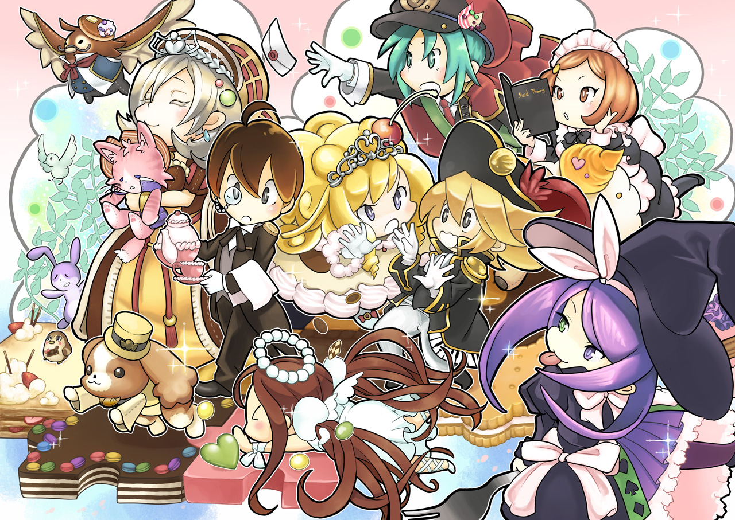
Madolche has always had 2 very serious problems.
- Consistency. The deck is extremely powerful when it gets to do its thing, but it lacks consistency. We have only six starters, compared to nine in Geargia, for example.
- Vulnerability to disruption. This comes from the fact that the deck is heavily reliant on its one Normal Summon per turn. When that Normal Summon is stopped, the deck can very easily find itself without a meaningful way to continue playing.
The standard solutions to these problems generally fall into two categories.
- Maximise the engine.
This is the approach taken by lists that play three Hootcake, two or more Gelato, two or more Mew, one or more Cruffssant, multiple copies of Madolche Ticket, Madolche Chateau, Madolchepalooza, and so on.
The idea is understandable: if the deck is inconsistent, play more Madolche cards.
The problem with this approach is that we are not actually increasing the number of starters, we are just hoping that the larger engine in combination with Madolche S/T support can stall or otherwise float into starters trough Madolche Ticket.
- Maximise non-engine in the form of protection or a supplementary engine.
In this approach, the remaining deck space is filled with extra traps and/or extenders and/or protection. The problem is that traps are normally positively traded with opposing deck only when our engine is also battling against opposing engine, while no engine and traps vs opposing engine is usually downhill battle. In other words, more traps will be very good when we already have our engine, but when we don't, we are still likely to lose, albeit we can survive for a turn or two more than we would otherwise. Protection doesn't work when we don't have anything to protect, and likewise extenders don't have anything to extend.
The only supplementary engine that I will mention in this article are the Hands. They, on the other hand (pun intended), are simply problematic because they need to be Normal Summoned, and thus they are competing with Madolche. They are also notably good only against opposing AT decks, vs other decks they range from »meh« to »bad«.
The Third Way
This is, of course, where the Artifact version comes in.
I can already hear the objection:
"But wait, every deck is doing that. Just throw Artifacts into everything. Very nice article, I don't care. Just play Geargia Artifact instead."
Please hear me out.
The fundamental idea is that we are taking the supplementary engine + more Traps + more extenders approach at the same time, while not adding a single non-Madolche Normal Summon.
That distinction is the entire point.
The real appeal of Artifacts is that they cover one of Madolche's biggest problems: forcing Anjelly through opposing backrow, naturally, while doing their own thing. Traditional Madolche builds are effectively forced to play Forbidden Lance for this purpose - a card that does nothing when there is no Madolche engine to protect. In the Artifact build, Ignition and Double Cyclone fill much of the same role, but proactively and independently: they clear the cards threatening Anjelly while simultaneously advancing the Artifact engine. Unlike Lance, they remain useful without a Madolche monster in sight. On the other side of the same Artifact coin, of course, they offer disruption and protection also during opponent's turn.
And the overlap goes both ways. Instant Fusion, Madolche's usual extender, works well alongside Artifacts for the price of one Extra Deck slot, while Call of the Haunted, traditionally an Artifact blowup card, becomes a genuine Madolche extender once monsters have accumulated in the Graveyard.
Having explained what is in my opinion the biggest strength of the variant, let us now look into some other particular advantages offered exclusively by this variation.
- Obviously and very notably, the Artifact version is not auto-losing Game One to floodgates (Skill Drain, Necrovalley…), due to having access to S/T spot removal as part of supplementary engine. Nor is it forced to Side (or Main) MST.
- Another obvious consequence of the above, and simply due to nature of Artifacts, is that traditionally horrible matchup - Spellbook - is UNSPEAKABLY improved.
- The famous Artifact FTK is present is this variation, adding a chunk of winrate. Stated less dramatically, Artifacts can win games of their own, even with a complete lack of Madolche engine. No other supplementary engine can do this.
- The Artifacts themselves can be additional fuel for Hoot effect.
- The Artifacts offer a handy turn-off button for Acid Golem, which can be somehow awkward to turn off in other variants.
- The Artifacts can, with the same procedure as above, turn off Flying C, or simply disuade the opponent from siding it in against us, anyway.
Conclusion
There is inevitably a cost to playing Artifacts, and I am not arguing that this variant solves every problem Madolche has. Most notably, the very first problem mentioned in this article, consistency, is largely ignored with this variant. But compared with the other two approaches mentioned, I think that Artifacts offer something uniquely valuable, while not competing with the Normal Summon and with each engine offering real synergy to the other with their respective extender / blowup cards (Call of the Haunted, Instant Fusion, S/T pops as a form of pushing Anjelly through): they increase the number of playable games when Madolche consistency fails, while simultaneously providing valuable interaction and support when the engine is present.
A decklist is not given because I hope this article encourages you to try and build your own.
Until next time,
Wisk.

